1.

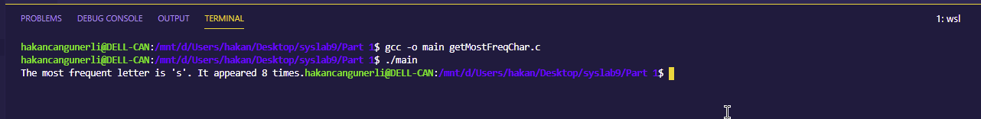

2.

a)

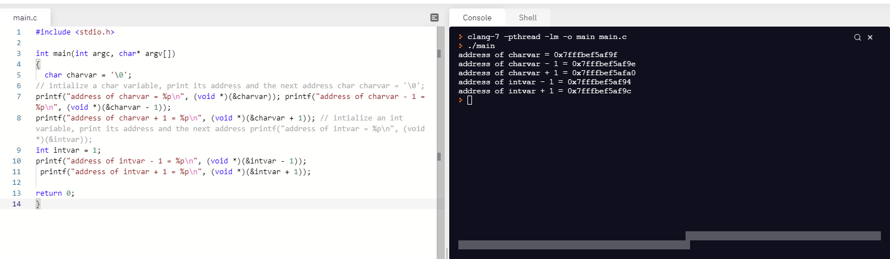

b)

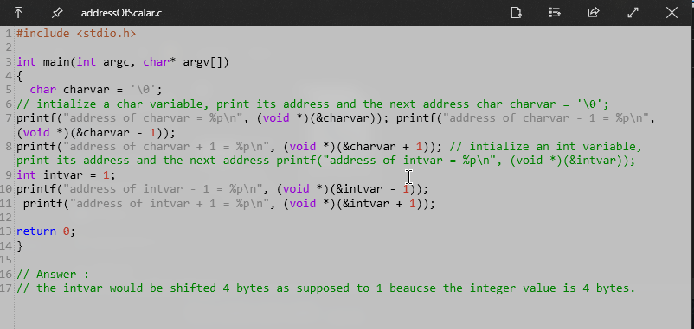

c) the intvar would be shifted 4 bytes since it is an integer, not a character which is 1 byte.

3.

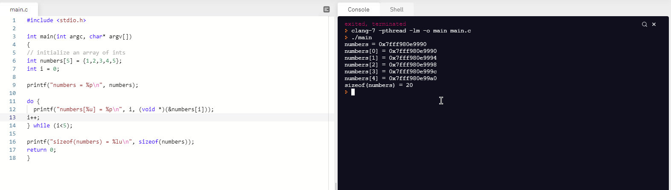

a)

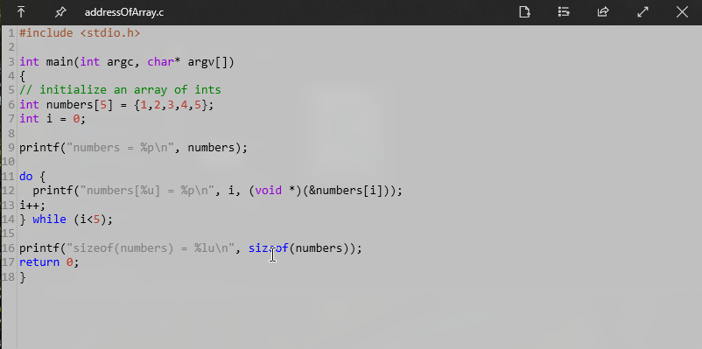

b) they are indeed the same.

c) printf(“the length of the array (numbers) = %lu \n”, sizeof(numbers)/sizeof(numbers[0]);